

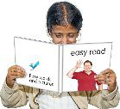

**Getting Ready to Stay in Hospital**

EasyRead version

**Welcome to Addenbrookes and the Rosie Hospitals**





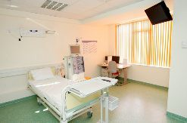







We want to make sure you are as comfortable as possible when you stay in hospital.

This EasyRead leaflet tells you what you need to know before you come.

**What time to get here and where to go**

You should have a letter that gives you details, it says:

•  what day and what time to come

•  the name of the ward to go to

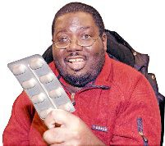



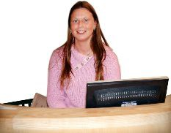

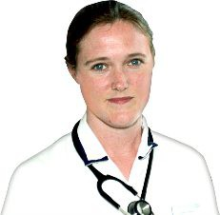

• the name of your doctor

• anything special you need to do like not eat or drink anything

• anything you need to do about the drugs you might be taking.

If you are not sure where to go ask at reception.

**On the day**





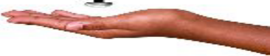



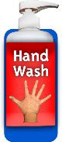



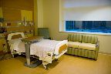



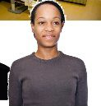

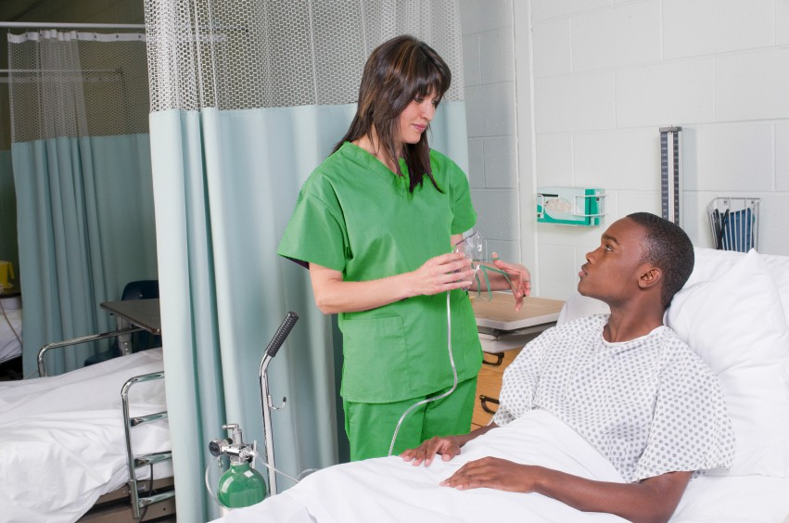

Please follow what it says in the letter. If you are not well or cannot come

please call us to let us know as soon as

you can.

**Staying with us**

Most of our wards have separate parts for men and women.

We have separate toilets as well.

Please use gel or wash your hands when you get to hospital, when you leave and other times when you might need to, like after using the toilet.

Each day we will talk to you about the care you are getting and details about when you might leave.

If you have any questions please ask staff on your ward.



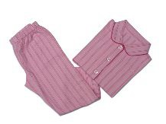



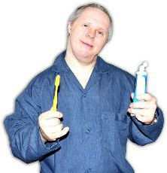

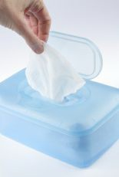

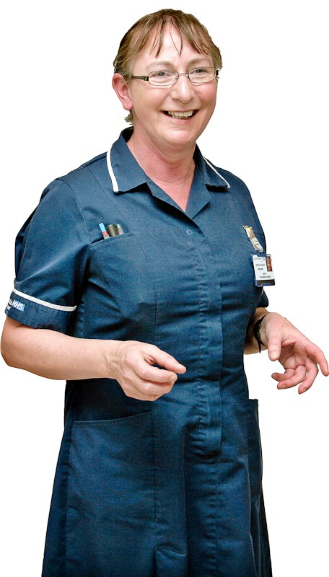

**What to bring with you**

You will need:

• pyjamas, dressing gown and slippers

• toothbrush, toothpaste and anything else you use to keep clean

• hand wipes

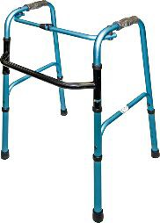









• your own clothes

• a small towel

• any mobility aids you have

• money for phone calls, TV and newspapers (ask us if you can use a mobile)











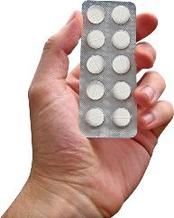

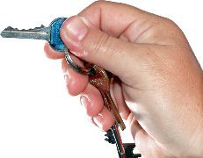

• things to pass the time like books or puzzles.

Don’t bring too much, you only have a small locker beside your bed.

Don't bring anything valuable, we can’t replace anything that is lost or stolen.

**Medicines to bring**

Please bring:

• all your medicines

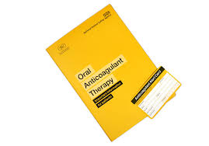

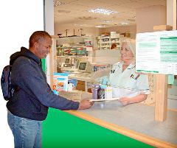

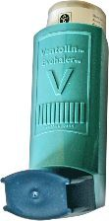

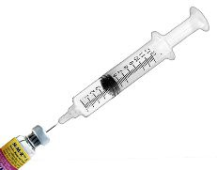

• any repeat prescription you have.



Any cards you have about your treatment.

Please tell us about all the medicines you use.

This includes:

• inhalers

• injections

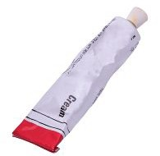





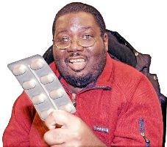



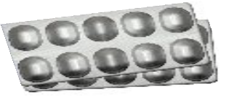

• creams

• patches.

Please ask us if you want to take your own medicines when you stay.

Let us know if you have any questions about your medicines.

**How to get to hospital**





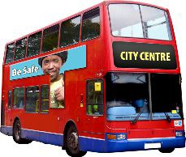



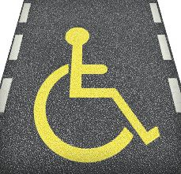

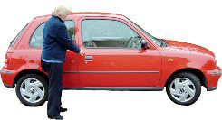

It is better to catch a bus or ask someone to bring you to hospital.

There are park and ride buses from

Babraham Road and Trumpington.

**Parking**

There is some parking at the hospital but it is always busy.

For people with badges there is disabled parking.

This is not free in ordinary parking spaces.

**Cheaper parking**



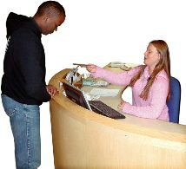

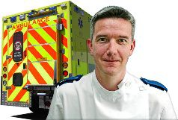

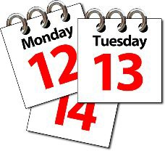

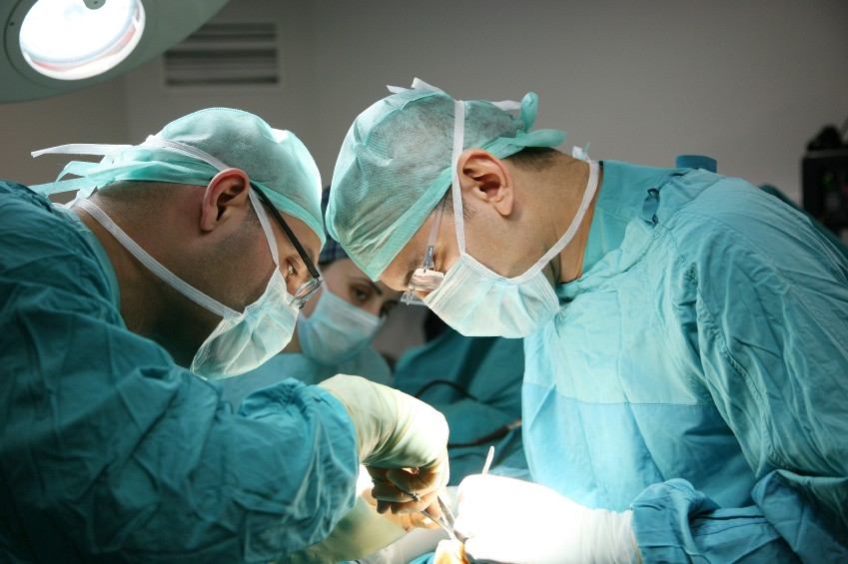

You can get cheaper parking tickets if you are:

• an outpatient

• having day surgery

• in the Emergency Department

• having treatment for two or more days together

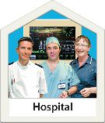

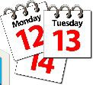





• coming to hospital a lot.

To get cheaper parking please take your ticket and the letter about your stay in hospital to main reception or the car park office near the car park exit.

Some people might need support from a familiar person when in hospital. The ward will give them a carer passport. Sometimes carers can stay overnight on the ward.

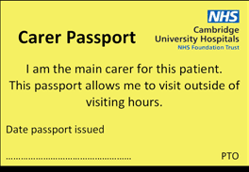

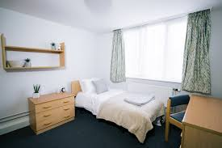

There is also a place to stay if family are not near home. Ask the ward about this.



Caring together has an office “one place” front of main reception for carer information.

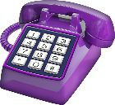

For travel help please call:

**01223 596060.**

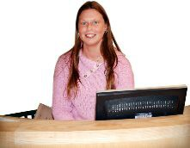



**Our telephone numbers**

Use the number on your letter or

waiting list office:

**01223 216460** or **01223 586919**



Main telephone:

**01223 245151**



**PALS (short for the Patients Advice and Liaison Service)**



PALS can help with information, advice and support.

They will listen to ideas you have about care or any complaints.



Telephone:

**01223 216756**



Email:

[**pals@addenbrookes.nhs.uk**](mailto:pals@addenbrookes.nhs.uk)

**Do you have a learning disability?**











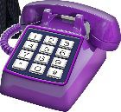

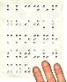





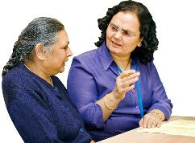

We have a learning disability nurse who can help or support you.

Please call:

**01223 216133**

**Need someone to talk to?**

Please call the chaplain on:

**01223 217769**

**Other formats**

If you need this leaflet in another format please call:

**01223 216032**

**Wi-Fi and Mobiles**









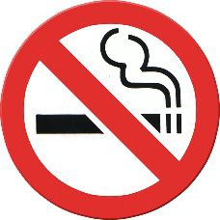



Please ask the staff on the ward about free Wi-Fi and using a mobile.

**No smoking**

You are not allowed to smoke anywhere on the hospital site.

For help to give up smoking ask your

GP or call the helpline on:

**0300 123 1044**

PIN3474, Version 3, October 2020